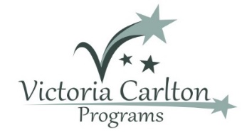
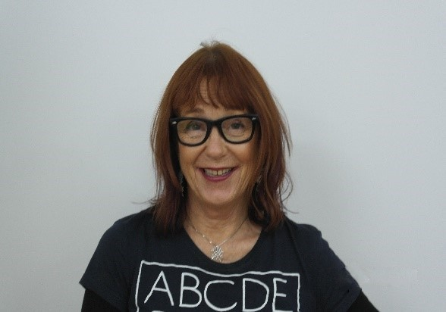
CREATIVE COURSES FOR HOLIDAYS
The Victoria Carlton Education Centre
July Holiday Programs
19 King William St Bayswater
92714200 or email iceinfo@iinet.net.au

Academic Boost: Monday the 10th to Friday the 14th of July (Half days 9.30-12.30)
A chance for children (Grade 1-9) to catch up and improve academic work before Term 3 starts. $75.00 for a 3-hour session (discounts for multiple sessions) Please bring a peanut free snack.
Art from the Heart: Monday the 10th, Wednesday the 12th & Friday the 14th of July (Half days 9.30-12.30)
Art workshops that link emotional intelligence with art/craft/puppetry
$75.00 per session for a 3-hour session. Please bring a nut free snack.
Eq4kidz: Monday the 10th to Friday the 14th of July (5 x Half Days 1-4 PM)
Our popular 5 session course to improve self-confidence, build motivation and develop resilience.
$480.00 for 5x3 hour sessions. Please bring a nut free snack to share with the group.
To book any of these courses ring us at 9271 4200

